

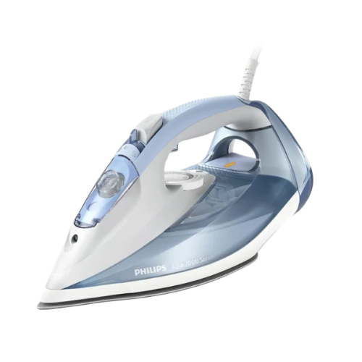**PhilipsHVSteamIronLight Blue**

• Quick Calc Release

• 2 m

• 220-240 V

• 50-60 Hz